INDUSTRIAL TRAINING REPORT

ON

DAYTRIPS

**Submitted in partial fulfillment of the requirement**

**FOR**

**Four Months Industrial Training**

**At**

**CS Soft Solutions Pvt. Ltd.**

**(From 8th January 2014 to 10th April 2014)**

**SUBMITTED BY**

NAVEEN RANA (1178434)

Sunaiya (1178466)

Master of Computer Applications

****

**Department of Computer Science**

**PUNJAB COLLEGE OF TECHNICAL EDUCATION, BADDOWAL,**

**LUDHIANA**

**PREFACE**

*Success doesn’t mean the absence of failures; it means the attainment of ultimate objectives. It means winning the war, not the battle***.**

**-**EDWIN C.BLIS

This project has been composed with the aim of covering a part of Masters of computer application syllabus as prescribed by PUNJAB TECHNICAL UNIVERSITY, JALANDHAR. A lot of effort has been made to make this project report interesting and a learning experience for the leader. The report has been explained with the help of diagrams and figures. The running project has presented through a CD representation. The subject matter has been compiled in a simple, illustrative and lucid manner.

**ACKNOWLEDGEMENT**

I take this opportunity to present my votes of thanks to all those guidepost who really acted as lightning pillars to enlighten our way throughout this project that has led to successful and satisfactory completion of this study.

I am really grateful to **Mr. Chhotu Sharma**  and **Mrs. Shalini Sharma** for their active support, whole-hearted guidance, sincere cooperation and pains-taking involvement during the study and in completing the assignment of preparing the said project within the time stipulated.

Lastly, I am thankful to all, particularly my team member, who have been instrumental in creating proper, healthy & conductive environment for me but without their help, it would have been extremely difficult for me to prepare the project in a time bound framework.

DECLARATION

I hereby certify that the work, which is being presented in the project entitled “DAY TRIPS ” By Naveen Rana and Sunaiya on completion for award of Degree of Masters of Computer Applications at PCTE , under department of Punjab Technical University, Jalandhar . It is an authentic of my own work.

Signature:

Naveen Rana(1178434)

Sunaiya(1178466)

**TABLE OF CONTENTS**

1. The Company Profile

2. Introduction

Project:

* Statement about problem
* Objective of project
* Scope of project
* Importance of project

3. Introduction about technology

* PHP
* MYSQL

4. SDLC(System Development Life Cycle)

* Prototyping Model: Requirement Analysis
* Hardware And Software requirement for Project
* System Analysis
* Identification of need
* Preliminary investigation
* Objective
* Feasibility Study
* Economical feasibility
* Technical feasibility
* Operational feasibility
* System Design
* Detailed description of “DAY TRIPS”
* Table Structure
* Design View of tables
* Stored Procedures
* Coding Phase
* Implementation
* Introduction
* Testing
* Maintenance
* Front End Used( PHP)
* Back-end used(MYSQL)

5.Conclusion

6. Bibliography

**Introduction about the Company**

**CS Group:**

CS Group founded by Mr. Chhotu Sharma is an amalgam of CS Infotech and CS Soft Solutions Pvt. Ltd. . CS Soft Solutions is a complete IT solutions providing company with huge clientele all over the world. CS Infotech is a pioneer institution which is engaged in providing computer education in Microsoft Technologies, to students as well as professional executives.

**CS InfoTech:**

CS InfoTech is a pioneer institution engaged in providing computer education to numerous students every year. The company provides comprehensive learning environment to individuals and is also engaged in honoring the technical skills of the professional executives to help them achieve excellence in their working fields. Students are also provided with opportunity to handle live projects during industrial training. The motive behind providing industrial training is to facilitate students with live projects and to keep them abreast of the latest technologies used in market. The institution takes immense pride in having empowered thousands of students across the entire region in all these years. CS Infotech has a good record of getting students placed in reputed firms.

**CS Soft Solutions Pvt. Ltd. :**

CS Soft Solutions is a complete IT solutions providing company based in Mohali. CS Soft Solutions was created to achieve the goal of providing its clients state-of-art web development services comparable with best in the world.

The services provided by CS Soft Solutions Pvt. Ltd. are

* Web Development
* Web Designing
* Online Marketing
* Mobile Application Development

CS Soft Solutions Pvt. Ltd. was conceptualized in October 2009 by Mr. Chhotu Sharma and Mrs. Shalini Sharma. The goal was to build a company that worked on solid principals, to develop world class IT products and provide a congenial environment and adequately encouraging work culture for all the team members at CS Soft Solutions Pvt. Ltd. Consequently, there is a huge clientele from all across the world. For assistance please refer to our website [www.cssoftsolutions.com](http://www.cssoftsolutions.com)

One of the methods of paying back to the industry that has been adopted by the CS Group is to recruit students from CS Infotech into CS Soft Solutions Pvt. Ltd. on the basis of their performance and ability to perform in the industry.

**Technology domain of the Company:**

* .Net Platform based Languages
* P.H.P.
* Java based Technologies
* C.M.S.
* Designing Suites

**Founders:**

**Mr. Chhotu Sharma** is the founder of the CS Group. He is a Microsoft Certified Software Developer and has been training IT professionals in different Microsoft Technologies since last 12 years. He is recognized as “The Guru of Microsoft Technologies”. For his excellent work in field of education, he has been conferred with title of “Himachal Gaurav” by the Chief Minister, Sh. Prem Kumar Dhumal in the year 2007.His students have been picked up by Fortune 500 companies including Microsoft, Accenture, TCS, Infosys and others. In the year 2009, he established CS Soft Solutions Pvt. Ltd, a company offering complete IT services in multifarious IT applications

**Mrs. Shalini Sharma** is Director of CS Soft Solutions Pvt. Ltd. and an adept teacher at CS Infotech. She is embodiment optimism and bears a sharp analytical acumen coupled with excellent People Management skills. She has trained thousands of students during last decade. She has expertise in a wide array of languages and she meticulously imparts technical training to her wards with endeavor to make them fully equipped in dealing with various requirements of the IT industry, in their careers.

**Introduction about the Project (Day Trips)**

The computer has brought revolution in every sphere of human life, whether it is business, education field, governance, medical science etc. The computer has reduced the human work load, businesses are going global and everything is available at the click of mouse. In any organization is using computer in almost every department.

The project named **Day Trips** is developed using PHP during the industrial training. This project has been developed in partial fulfillment of Requirements for the degree of (MCA) from (PCTE).

A lot of us have multiple online profiles scattered across various services, including Face book, LinkedIn, Flickr, and Twitter. And one problem we face is pulling all of this information together to build a single on-line identity — be it for personal use, or to create a professional on-line profile. We've focused on enabling you to: Quickly build a personal and dynamic splash page that points visitors to your content from around the web.

|  |  |  |
| --- | --- | --- |
| **Company Name** | : | CS Soft Solutions Pvt.Ltd |
| **Institute Name** | : | PCTE |
| **Project Title** | : | Day Trips |
| **Project Category** | : | Web Based Application |
| **Development Tools** | | |
| **Front End** | : | PHP 5.5, HTML, CSS |
| **Back End** | : | MS SQL 5.6 |

Project DESCRIPTION

DayTrips is a site that lets you find and share the best day trips in most interesting cities around the world.“Frightened by the thought of exhaustive week-long itineraries”DayTrips is a way to provide an easy way to take vacations one day at a time. The aim of the site is double: on the one hand, turning your own city exploration into a more exciting experience; on the other, providing access to an “ever-expanding library of trips in places that life may take you.“  Once you choose your destination, you will find all the information necessary to get away for a day! Then check out [DayTrips](http://like.allmyfaves.com/like/site/name/dayzipping.com" \t "_blank) to find and share the day trips you never knew you could take in cities just like this.

**Modules**

# The modules for project are:

# User Account Maintenance

* Admin
* User

**Importance of the Day Trips**

The Project Day Trips will be beneficial in the following way:

* From User’s Point of view:line2
* Easy to Use
* Easily available anywhere using internet
* Saves time and money
* Accurate and efficiently available information
* Less efforts
* Attractive designs and interactive

**Introduction about Technology used**

PHP is a server-side scripting language designed for web development but also used as a general-purpose programming language. PHP is now installed on more than 244 million websites and 2.1 million web servers. Originally created by Rasmus Lerdorf in 1995, the reference implementation of PHP is now produced by The PHP Group. While PHP originally stood for Personal Home Page, **it now stands for PHP: Hypertext Preprocessor, a recursive acronym.**

PHP code is interpreted by a web server with a PHP processor module which generates the resulting web page: PHP commands can be embedded directly into an HTML source document rather than calling an external file to process data. It has also evolved to include a command-line interface capability and can be used in standalone graphical applications.

PHP is free software released under the PHP License, which is incompatible with the GNU General Public License (GPL) due to restrictions on the usage of the term PHP.

PHP can be deployed on most web servers and also as a standalone shell on almost every operating system and platform, free of charge.

**Why PHP?**

Php run perfectly on different operating system such as window,linux,unix and so on.

Php is compatible with almost all web servers used today(apache ).

Php is free to download from the official php resource: http://www.php.net.

Php is easy to learn and runs efficiently and swiftly on any compatible web server.

**History**

Rasmus Lerdorf together with Andi Gutmans and Zeev Suraski, who rewrote the parser that formed PHP .

PHP development began in 1994 when the developer Rasmus Lerdorf wrote a series of Common Gateway Interface (CGI) Perl scripts, which he used to maintain his personal homepage. The tools performed tasks such as displaying his résumé and recording his web traffic.He rewrote these scripts in C for performance reasons, extending them to add the ability to work with web forms and to communicate with databases and called this implementation "Personal Home Page/Forms Interpreter" or PHP/FI. PHP/FI could be used to build simple, dynamic web applications. Lerdorf initially announced the release of PHP/FI as "Personal Home Page Tools (PHP Tools) version 1.0" publicly to accelerate bug location and improve the code.This release already had the basic functionality that PHP has today. This included Perl-like variables, form handling, and the ability to embed HTML. The syntax was similar to Perl but was more limited and simpler, although less consistent.[3] A development team began to form and, after months of work and beta testing, officially released PHP/FI 2 in November 1997.

Zeev Suraski and Andi Gutmans rewrote the parser in 1997 and formed the base of PHP 3, changing the language's name to the recursive acronym PHP: Hypertext Preprocessor. Afterward, public testing of PHP 3 began, and the official launch came in June 1998. Suraski and Gutmans then started a new rewrite of PHP's core, producing the Zend Engine in 1999. They also founded Zend Technologies in Ramat Gan, Israel.

On May 22, 2000, PHP 4, powered by the Zend Engine 1.0, was released. As of August 2008 this branch is up to version 4.4.9. PHP 4 is no longer under development nor will any security updates be released, who wrote the original Common Gateway Interface (CGI) component,

**MySQL**

MySQL is the world's most popular open source database software, with over 100 million copies of its software downloaded or distributed throughout it's history. With its superior speed, reliability, and ease of use, MySQL has become the preferred choice for Web, Web 2.0, SaaS, ISV, Telecom companies and forward-thinking corporate IT Managers because it eliminates the major problems associated with downtime, maintenance and administration for modern, online applications.

Many of the world's largest and fastest-growing organizations use MySQL to save time and money powering their high-volume Web sites, critical business systems, and packaged software — including industry leaders such as Yahoo!, Alcatel-Lucent, Google, Nokia, YouTube, Wikipedia, and Booking.com.

The flagship MySQL offering is MySQL Enterprise, a comprehensive set of production-tested software, proactive monitoring tools, and premium support services available in an affordable annual subscription.

MySQL is a key part of LAMP (Linux, Apache, MySQL, PHP / Perl / Python), the fast-growing open source enterprise software stack. More and more companies are using LAMP as an alternative to expensive proprietary software stacks because of its lower cost and freedom from platform lock-in.

MySQL was originally founded and developed in Sweden by two Swedes and a Finn: David Axmark, Allan Larsson and Michael "Monty" Widenius, who had worked together since the 1980's

**Introduction to Software Development Life Cycle(SDLC)**

The Systems Development Life Cycle (SDLC) is a conceptual model used in project management that describes the stages involved in an information system development project from an initial feasibility study through maintenance of the completed application. Various SDLC methodologies have been developed to guide the processes involved including the waterfall model (the original SDLC method), rapid application development(RAD), joint application development (JAD), the fountain model and the spiral model. Mostly, several models are combined into some sort of hybrid methodology. Documentation is crucial regardless of the type of model chosen or devised for any application, and is usually done in parallel with the development process. Some methods work better for specific types of projects, but in the final analysis, the most important factor for the success of a project may be how closely particular plan was followed. The following figure shows a general life cycle Process in software development:

**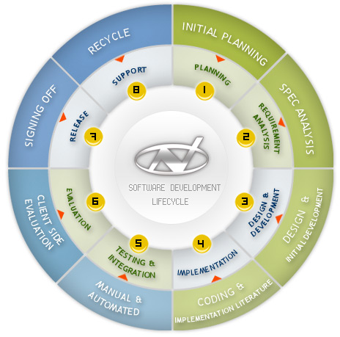**

The most common steps in all the development methodologies are as follows:

1. **System/Information Engineering and Modeling:** As software is always of a large system (or business), work begins by establishing the requirements for all system elements and then allocating some subset of these requirements to software. This system view is essential when the software must interface with other elements such as hardware, people and other resources. System is the basic and very critical requirement for the existence of software in any entity. So if the system is not in place, the system should be engineered and put in place. In some cases, to extract the maximum output, the system should be re-engineered and spruced up. Once the ideal system is engineered or tuned, the development team studies the software requirement for the system.
2. **Software Requirement Analysis:** This process is also known as feasibility study. In this phase, the development team visits the customer and studies their system. They investigate the need for possible software automation in the given system. By the end of the feasibility study, the team furnishes a document that holds the different specific recommendations for the candidate system. To understand the nature of the program(s) to be built, the system engineer or "Analyst" must understand the information domain for the software, as well as required function, behavior, performance and interfacing. The essential purpose of this phase is to find the need and to define the problem that needs to be solved.

### Server Side:

* **Software Requirements (Recommended):**
* Developing Language:
* PHP 5.5 With html,css
  + - * Database:
* My SQL 5.6
  + Operating System:
* Any operating system
* **Hardware Requirements (Recommended):**
  + - * Processor:
* Pentium 3 or above.
  + - * Processor speed:
* Greater than 400MHz**.**
  + - * Ram:
* Greater than 1GB**.**
  + - * Hard Disk:
* Minimum 40GB.

### User Side (Recommended):

* **Software Requirements:**
* Browser
* Internet Connection
* **Hardware Requirements:**
  + Processor:
    - Pentium 3 or above.
  + Video Device:
    - Monitor or any other video screen
  + Processor speed:
    - Greater than 500MHz**.**
  + Ram:
    - Greater than 1GB**.**
  + Hard Disk:
    - Minimum 20GB.
* Modem:
* For Internet Connection

1. **System Analysis and Design:** In this phase, the software development process, the software's overall structure and its nuances are defined. A software development model is thus created. Analysis and Design are very crucial in the whole development cycle. Any glitch in the design phase could be very expensive to solve in the later stage of the software development. Much care is taken during this phase. The logical system of the product is developed in this phase.
2. **Code Generation:** The design must be translated into a machine-readable form. The code generation step performs this task. If the design is performed in a detailed manner, code generation can be accomplished without much complication. Programming tools like compilers, interpreters, debuggers etc are used to generate the code. Different high level programming languages like are used for coding. With respect to the type of application, the right programming language is chosen.
3. **Testing:** Once the code is generated, the software program testing begins. Different testing methodologies are available to unravel the bugs that were committed during the previous phases. Different testing tools and methodologies are already available.
4. **Maintenance:** The software will definitely undergo change once it is delivered to the customer. There can be many reasons for this. Change could happen because of some unexpected input values into the system. In addition, the changes in the system could directly affect the software operations. The software should be developed to accommodate changes that could happen during the post implementation period.

**Analysis Phase**

Analysis is detailed study of various operation performed by system and their relationship within and outside the system. Outside factor also plays the major role in the system like government, customers etc. one aspect of the analysis is defining the boundaries of the system and determining whether or not a candidate system should consider other related systems. In analysis phase, the analysis collects a great deal of relatively unstructured data through:-

* Interviews
* Questionnaires
* Observation
* Procedures

After the analysis phase we have with us the details of the existing system and the requirements of the user for the new system. This phase diverts focus from the problem domain to the solution domain. It acts as a bridge between the requirement phase and its solution. The design phase focuses on the detailed implementation of the system recommended in the feasibility study. Emphasis is on translating performance specifications into design specifications.

**Feasibility Study**

In feasibility study we analyze our proposed solution for being feasible or not.

The term “feasibility study” is used as a convenient description for the output for the work done. Users of this toolkit should not apply preconceived notions of what a feasibility study consists of. Stated as simply as possible, the work done here must show that the project:

* is in accordance with predetermined needs;
* is the most suitable technical solution to the needs;
* can be implemented within any capacity constraints of the Institution which operates;

A feasibility study is the test of a system proposal according to the workability impact on organization, ability to meet user needs and effective use of resources. The objective of the feasibility study is not to solve the problems but to acquire the sense of scope. During the study, the problem definition is crystallized and the aspects the problem to be included in the system is determined. After the initial investigation of the system that helped to have the depth study of existing system, understanding its strengths and weaknesses and the requirements for the new proposed system.

Under this we take into consideration three types of feasibility studies.

* Behavioral Feasibility
* Technical Feasibility
* Economic Feasibility

1. **ECONOMICAL FEASIBILITY:-** Economic feasibility is the most frequently used method for evaluating the effectiveness of candidate system. More commonly known as cost/benefit analysis, the procedure is to determine the benefits and savings that are expected from a candidate system and compare them with the costs. If benefits outweigh the costs, then the decision is made to design and implement the system. The project is economically feasible as the only cost involved is having a computer with the minimum requirements mentioned earlier. For the users to access the application, the only cost involved will be in getting access to the Internet.

Our project “Day Trips “ is economically feasible. In this project we use the php language and for data storage we use the MySQL. it is economical feasible because PHP is open source means license free so there is no need to buy PHP software externally. The data storage we do not need to buy the MYSQL, because it is also free.

**2. TECHNICAL FEASIBILITY:-**  Technical feasibility centers on the existing computer system. (Hardware/Software) and to what extent it can support the proposed addition also the organization already has sufficient high end machines to serve the processing requirements of the proposed system.

The project is technically feasible as the technology involved in the project is easily available. To deploy the application, the only technical aspects needed are mentioned below:

**Operating Environment:** any OS

**Platform:** php

**Database:**  mysql 5.6

**For Users:** Internet Browser & Internet Connection

Our project Day Trips is technical feasible because in this project we can add property information and search property information. All these things are technically feasible. In our project, if we want to add new category or new folder etc. , then simply we click on add new and store information regarding changes into database.

1. **OPERATIONAL FEASIBILITY:-** Operational feasibility is evaluation is to determine whether system is operationally acceptable .during this study it was determine whether the system will operate in the way that user wants or not.

Our project is also operational feasible because in this project we provide the graphical user interface (GUI) which is easy to understand & operate. it also provide the user friendly interface. the user will easily use the system .In this project we use the buttons, text box, images which is easily understandable for end user.

The system will be used if it is developed well skill then be resistance for users that undetermined

1. No major training and new skills required as it is based on DBMS model.
2. It will help in the time saving and fast processing and applications.
3. New product will provide all the benefits of present system with better performance.
4. Improved information, better management and collection of the reports.
5. Use support.
6. User involvement in the building of present system is sought to keep in mind the user specific requirement and needs.

**Three-Tier Web Application Development**

In web application development, we use three-tier architecture refers to separating the application process into three specific layers. What the user sees via a web browser is called the presentation tier and is content served from a web server. The middle tier performs the business logic processing that occurs, for example, when a user submits a form. The back end consists of the data tier which handles the database processing and access to the data. We'll take a simplistic look at each of these.

**1. Presentation Tier:** The Presentation Tier or User Interface is the portion the user sees when they open a web page in the browser. It is as simple as you reading this article all the way to searching a catalog and purchasing a product using a shopping cart. It is what is presented to the user on the client side within their web browser. **Languages used in this layer are php, HTML, CSS and JavaScript.**

**2. Business Logic or Application Tier:** The Business Logic, Functional Process Logic, Business Rules (all pertaining to the same thing), are kept in a separate layer. In php, this is where you define your classes and source code. This can be in the App\_Code folder for your classes and methods. You would not use HTML or Javascript in this layer. In this layer you typically define your classes, functions, sub procedures, properties,etc.   
 **3. Data Access Tier:** In Php, the Data Access layer is where you define your typed datasets and table adapters. It is where you define your queries or stored procedures. The business tier may then make use of this functionality. In your classes, rather than defining ad hoc queries, you may use a Table Adapter to access the Data Access Layer.

**Benefits:**When utilized properly, using a multi-tier architecture improves performance and scalability. If a web page needs an update or redesign, all of this may be handled by altering the CSS and HTML, without affecting the business or data logic. Any of the three tiers may be replaced or upgraded individually without affecting the other tiers. For instance, if you change the database on the back end, it wouldn't affect the presentation or business logic tiers, other than changing the database connection.

**Design Phase**

The most creative & challenging phase of the system life cycles . Systems design is the process or art of defining the architecture, components, modules, interfaces, and data for a system to satisfy specified requirements. One could see it as the application of systems theory to product development. There is some overlap with the disciplines of systems analysis, systems architecture and systems engineering.

System design. It involves the conceiving, planning out & specifying the externally observable characteristics of the software product. It is the most time consuming phase & includes user displays report format external data sources & functional characteristics.

**The term design describes the final system & the process by which it is develop. System design is the process of the problem solving & planning for software solution.**

The first step is to **determine how the output is to be produced** **& in what format**. Samples of the output are also presented & second step input data & database have to be design to meet the requirement of the purposed output.

The actual description of the problem, how the job will be solved, what is the procedure for solving the problem are main issues.

A procedure can be explained with flow charts, dataflow diagram more easily.

**1**.**The External Design**

External design consists of conceiving, planning out and specifying the externally observable characteristics of the software product. These characteristics include user displays or user interface forms and the report formats, external data sources and the functional characteristics, performance requirements etc. External design begins during the analysis phase and continues into the design phase.

**2.Physical design**

The physical design relates to the actual input and output processes of the system. This is laid down in terms of how data is input into a system, how it is verified/ authenticated, how it is processed, and how it is displayed as output. Physical design, in this context, does not refer to the tangible physical design of an information system. To use an analogy, a personal computer's physical design involves input via a keyboard, processing within the CPU, and output via a monitor, printer, etc. It would not concern the actual layout of the tangible hardware, which for a PC would be a monitor, CPU, motherboard, hard drive, modems, video/graphics cards, USB slots, etc.

**3.Logical design**

The logical design of a system pertains to an abstract representation of the data flows, inputs and outputs of the system. This is often conducted via modeling, which involves a simplistic (and sometimes graphical) representation of an actual system. In the context of systems design, modeling can undertake the following forms, including:

* Data flow diagrams

**DATA FLOW DIAGRAMS (DFDs)**

A data flow diagram, in the simple words, is a hierarchical graphical model of a system that shows the different processing activities or functions that system performs and the data interchange in this function. In the DFD terminology, it is useful to consider each function as process that consumes some input data & produces some output data.

The DFD (also known as the bubble chart) is a simple graphical formalism that can be used to represent a system in terms of the input data to the system, various processing carried out on this data & output data generated by the system. DFD is very simple formalism. It is simple to understand & use. A is use very limited number of primitive symbols to represent the functions performed by a system & the data flow among these functions.

Human mind is such that it can easily understand any hierarchical model of a system, because in a hierarchical model, starting with a very simple & abstract model of a system; different details of the system can be slowly introduced through different hierarchies

**Primitive symbols Used For Constructing DFD’s:**

**1. Function symbol:-**

A function symbol is representing as circle. This symbol is called a PROCESS or a BUBBLE. Bubbles are annotated with the names of corresponding Functions. It represents a process that transforms incoming data flow into the outgoing data flow.

**2. External entity Symbol:-**

**External Entity**

An external entity such as a manager, customer etc. is represented by a rectangle. The external entities are essentially those physical entities external to the software, which interact with the system by inputting data to the system or by consuming the data produced by the system. In other words, it defines the source or destination of the system data.

**3. Data Flow Symbol:-**

An arrow identifies data flow in the motion. A arrow represent the data flow occurring between two processes, in which direction of the data flow arrow.

**4. Data Store Symbol:-**

An open rectangle is a data store – data at rest, or a temporary repository of data.

**DFD of Day Trips**

**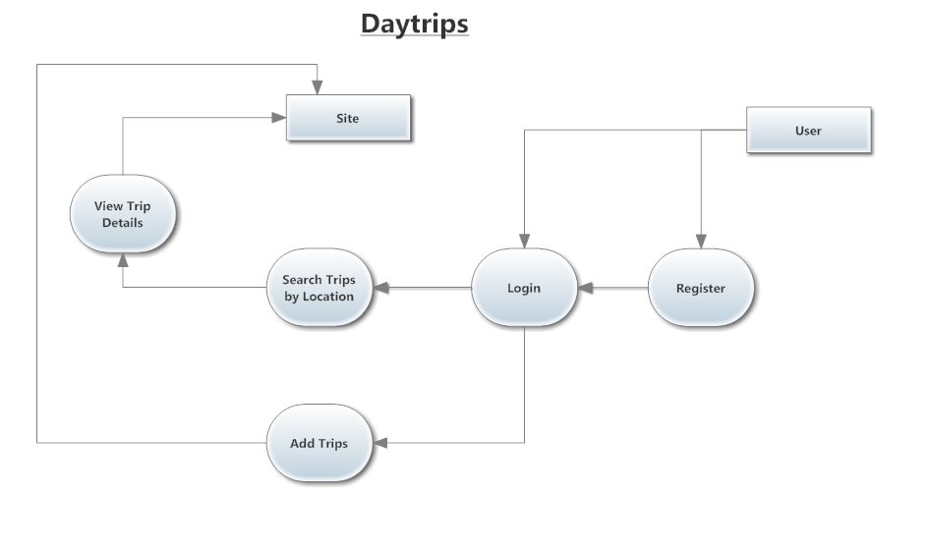**

**Database Of Day Trips**

**Tables :** Total 5 tablesare there in our project.

1. tbcnt
2. tbcty
3. tbreg
4. tbtrip
5. tbtrippic

**Tables with their Attributes :**

**1.tbcnt**

**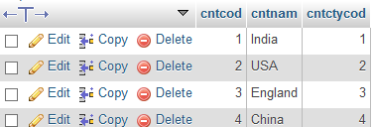**

**2.tbcty**

**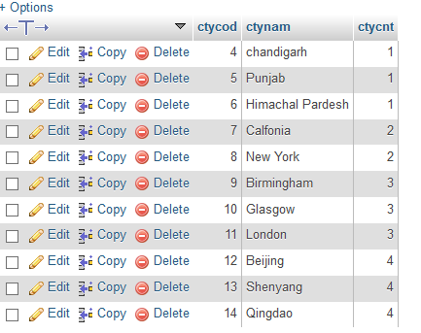**

**3.tbreg**

**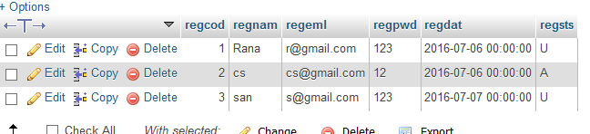**

**4.tbtrip**

**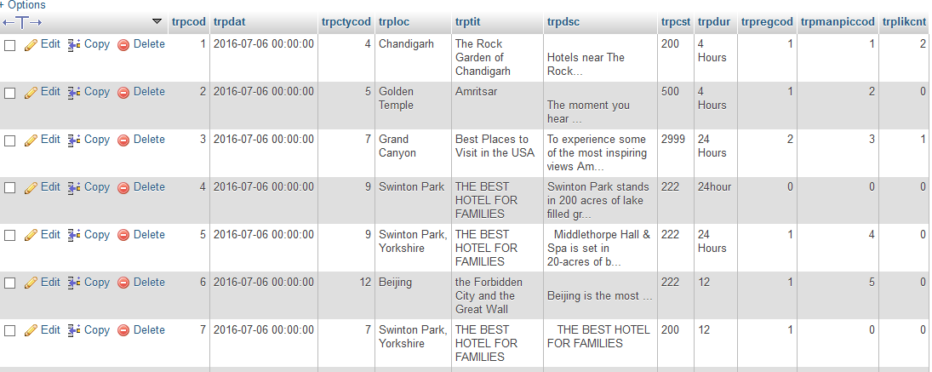**

**5.tbtrippic**

**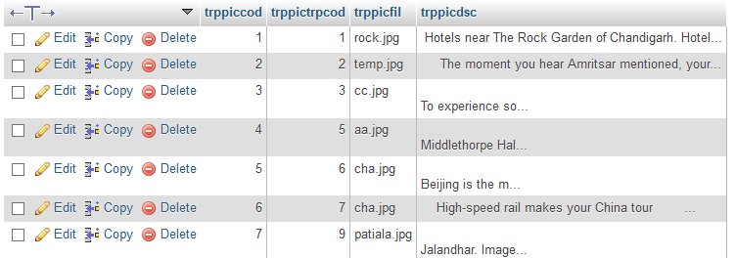**

**Screenshot:**

**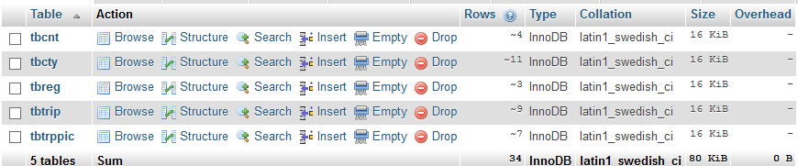**

**Stored Procedures:**

25 Stored procedures are there in our project.

Each table has 5 stored procedure :

1. For insert
2. For delete
3. For update
4. For display
5. For find

Therefore 5 tables are there in project so 45 stored procedures are there in our project.

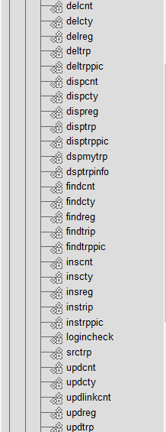

**Coding phase**

The design is complete; most of the major decisions about the system have been made. **After designing the new system, the whole system is required to be converted into computer understanding language.** The goal of the coding phase is to translate the design of the system into code in a given programming language for a given design. The aim of this phase is to implement the design in the best possible manner. The coding phase affects both the testing &maintenance profoundly. A well written code reduce the testing & maintenance effort .since the testing &maintenance cost of software are much higher than coding cost .During the coding focus should be on developing programs that are easy to write

The design must be translated into machine readable form. The code generation step performs this task if the design is performed in a detailed manner, code generation can be accomplished without Much complication, programming language are used for coding & the right programming language is chosen

This is also called programming phase in which the programmer convert the program specification into computer instruction which be refer as programs. The program coordinates the data movements & controls the entire process in a system.

It is generally felt that the program must be modular in nature . This helps in fast development, maintenance & future change, if required.

This means program construction with procedural specification has finished and the coding for the program begins:

* Once the design was over, coding commenced
* Coding is natural consequence of design.
* Coding step translate a detailed design representation of software into a programming language realization.
* Main emphasis while coding was on style so that the end result was an optimal code.

Following points were kept into consideration while coding:

**Coding Style:** The structured programming method was used in all the modules the project. It incorporated the following features-

* The code has been written so that the definition and implementation of each function is contained in one file.
* A group of related function was clubbed together in one file to include it when needed and save us from the labor of writing it again and again.

**Naming Convention:** As the project size grows, so does the complexity of recognizing the purpose of the variables. Thus the variables were given meaningful names, which would help in understanding the contents and purpose of variable.

* The function names are also given meaningful name that can be easily understood by the user.

**Indentation:** Judicious use of indentation can make the task of reading and understanding a program much simpler. Indentation is an essential part of a good program. If code id intended without thought it will seriously affect the readability of the program.

* The higher –level statements like the definition of the variables, constants and the function are intended, with each nested block intended, starting their purpose in the code.
* Blank line is also left between each function definition to make the code look neat.
* Indentation for each source file starting the purpose of the file is also done.

**Implementation phase**

System implementation is the stage when the user has thoroughly tested the system and approves all the features provided only after all the requirements are meet and the user is satisfied.

The new system may be totally new; replacing an existing manual or automated system, or it may be a major modification to an existing system. In either case, proper implementation is essential to provide a reliable system to provide a reliable system to meet organizational requirements. Successful implementation is successful implementation may not guarantee improvement in the organization using the new system, but improper will prevent it.

Implementation is the process of having system personal check out and put new equipment into use, train users, installs the new application and constructs any files of data needed to use it. This phase is less creative than system design. Depending on the size of the organization that will be involved in using the application and the risk involved in its use, system developers may choose to test the operation in only one area of the firm with only one or two persons. Sometimes, they will run both old and new system in parallel way to com-pare the results. In still other situations, system developers stop using the old system one day and start using the new one the next.

The implementation of web based or lain based networked project has some extra step at the time of implementation. We need to configure the system according the requirement of the software.

For the project we need to install and configure web logic server 9.1 database servers, and the deployment directory for the project.

**A crucial phase in the system development life cycle is the successful implementation of the new designed system implementation. It includes all those activities that take place to convert from the old system to the new system**. The new system is here replacing an existing manual system. The proper implementation become necessary so that a reliable system based on the requirement of the organization can be provided. Successful implementation guarantees improvement in the organization working.

Finally the actual implementation requires launching of the web site and fulfills the required formalities with the concerned authority and feeding of all the information required in the database. Thus, implementation is vital step in ensuring the success of new system. Even well-designed system can fail if it is not properly implemented.

**Implementation Tools**

The project was implemented using PHP server page, HTML, net beans. The implementation work was carried out in window XP/2000 server platform.

1. PHP
2. MYSQL

**Implementation Activities**

* Acquisition of hardware, software &services
* Software development or modification
* End user training
* System documentation & installing

**Screen Shots Of Project**

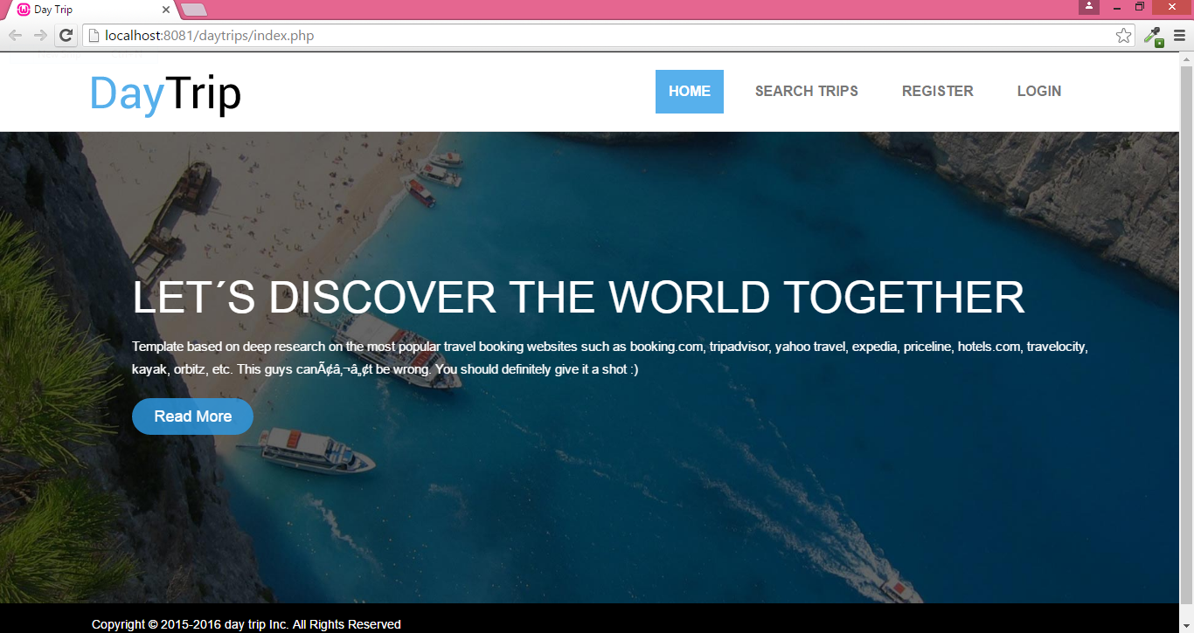

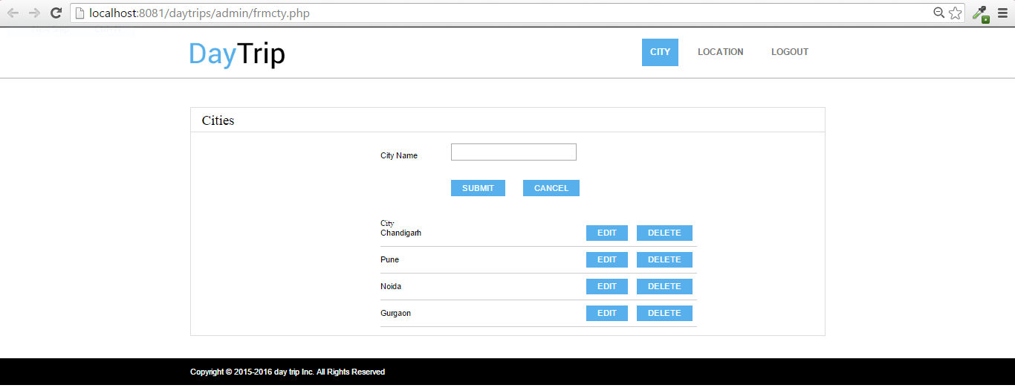

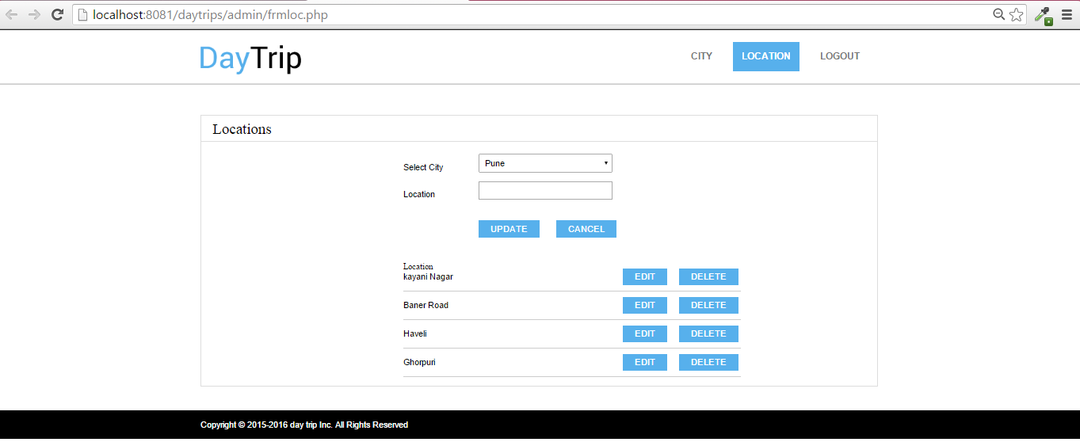

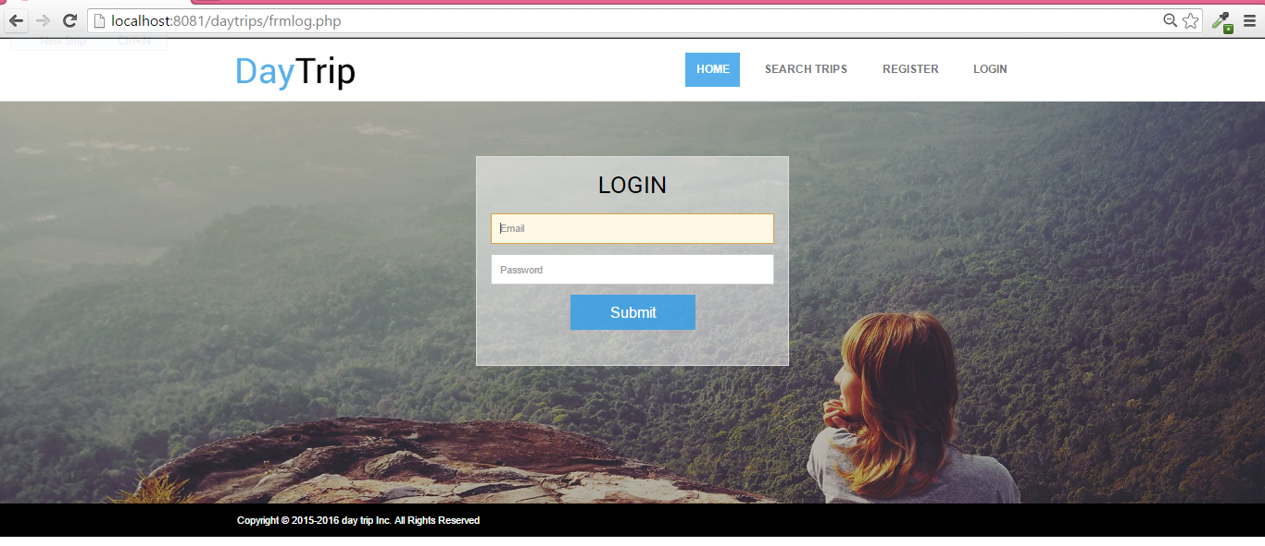

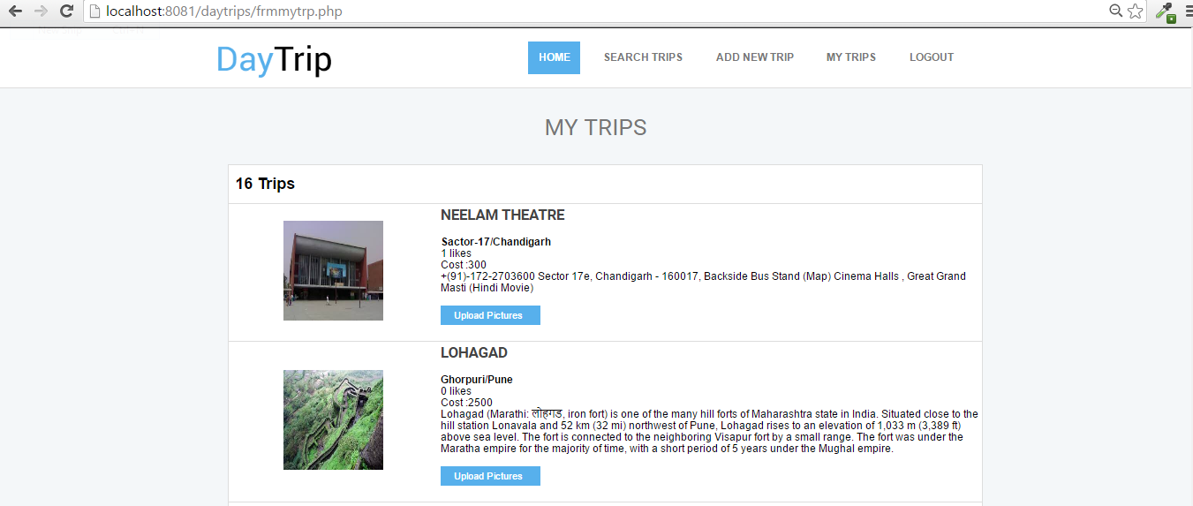

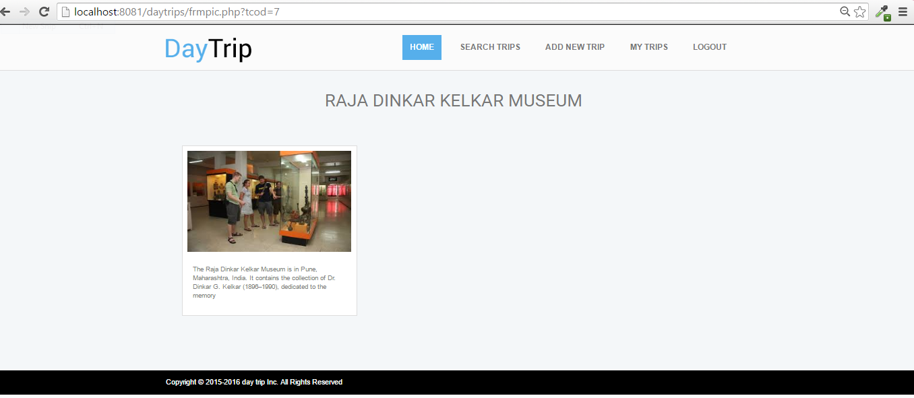

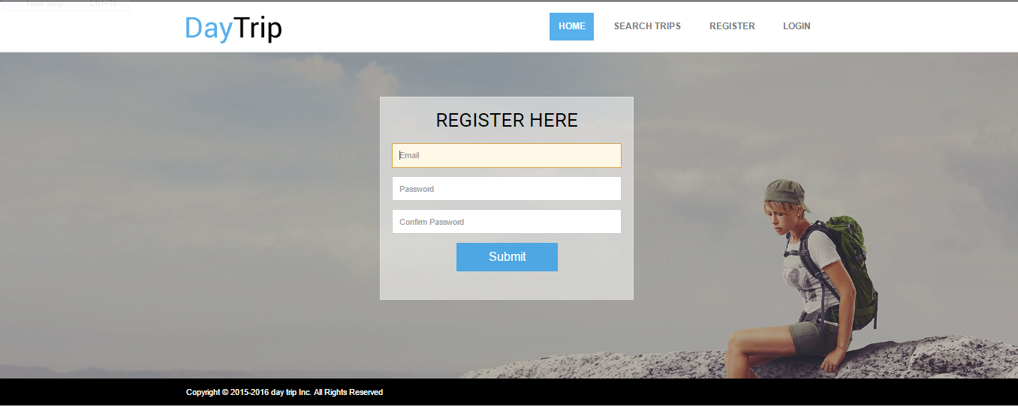

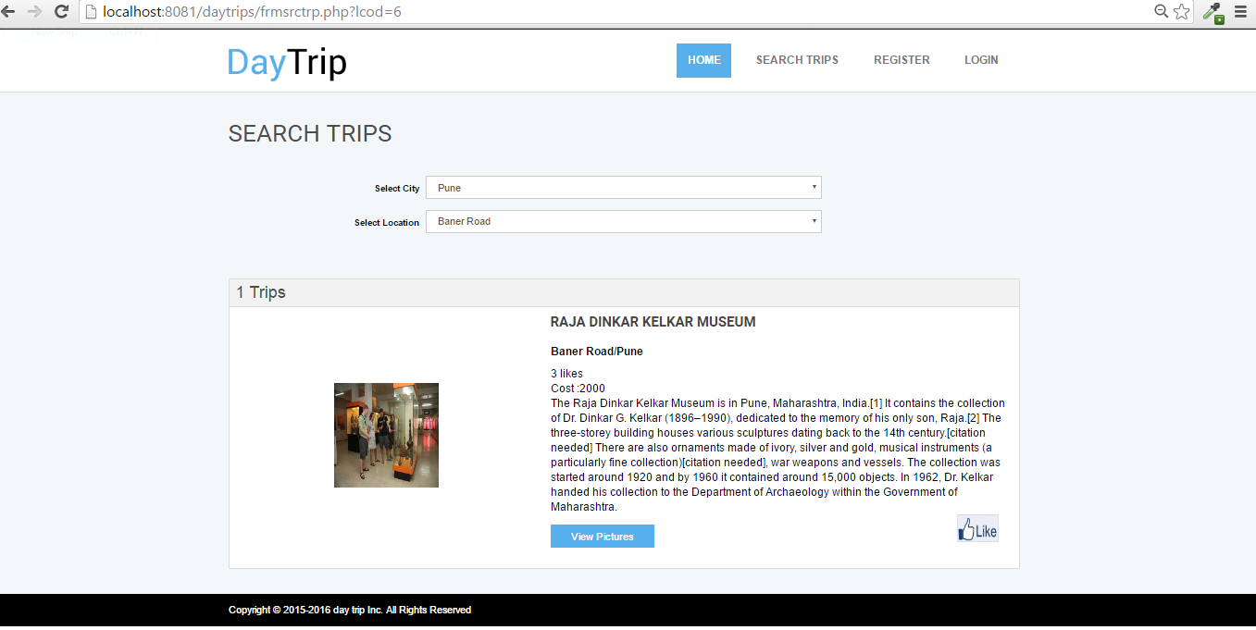

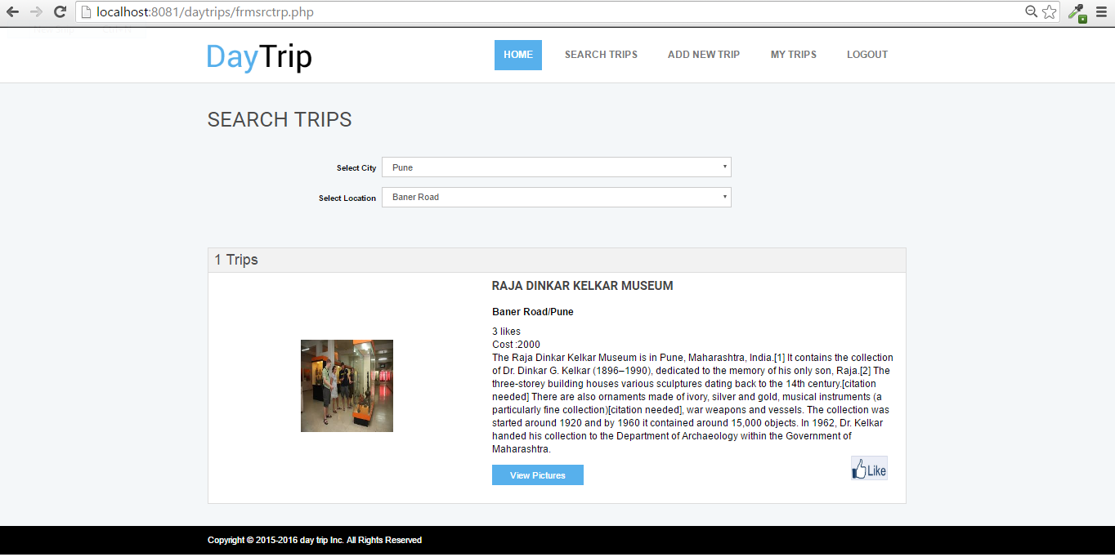

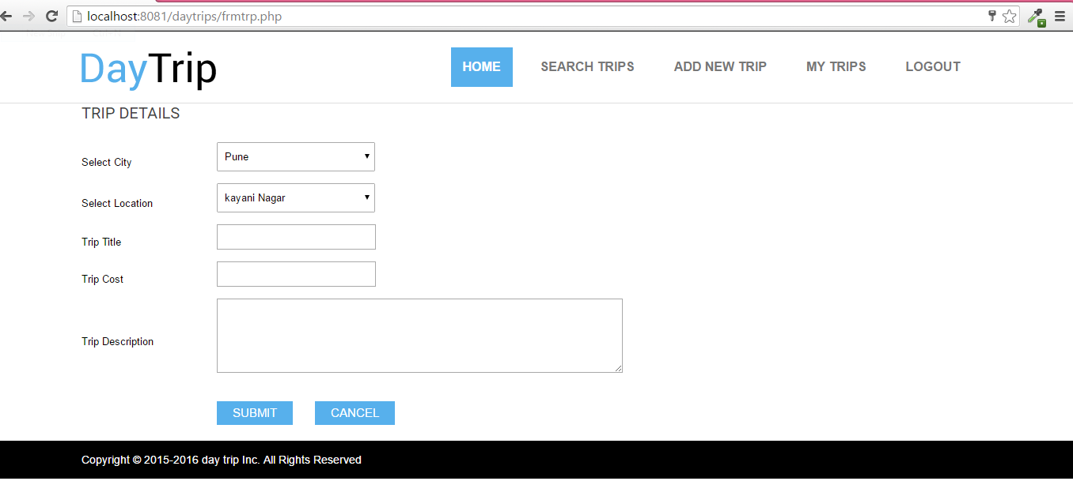

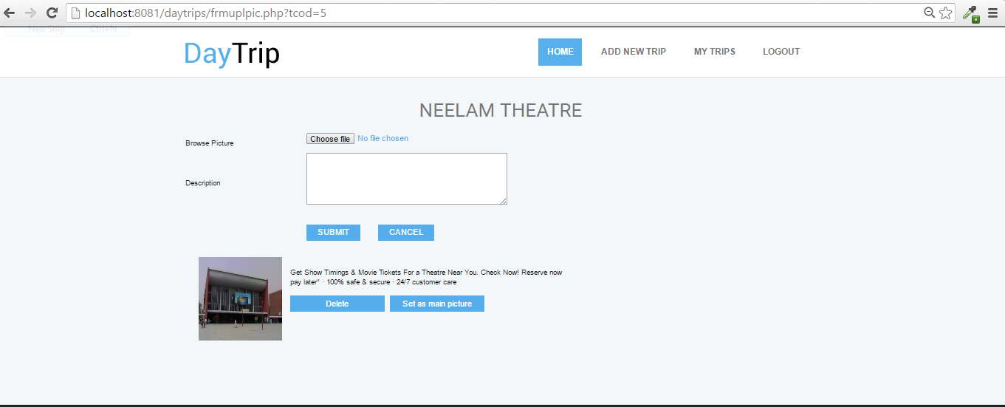

**Testing phase**

Before actually implementing the new system into operation, a test run of the system is done removing all bugs, if any. It is an important phase of a successful system. After codifying the whole program of the system, a test plan should be developed on run on a given set of test data. The output of the test run should match the expected result.

Testing is a process of executing a program with the intent of finding an error. A good test case is on that has high probability of finding an as yet undiscovered error. No program or system is perfect, communication between user and designer is not always clear. The result is error and error. So testing performs a main role in developing software.

In this phase, the system is tested normally programs are written as series of individual modules, these subjects separated& detailed test .The system is then tested as whole .The separated modules are brought together & tested as complete system. The system is tested to ensure that interface between modules work (integration testing) the system work on the intended platform with the expected volume of the data (volume testing) & that the system does what the user require (beta testing). System testing involves testing hardware devices & debugging computer programs, testing information processing procedures.

**The effectiveness and efficiencies of software testing depends on how well the testing process integrates with the overall development environment as well as how efficient the testing techniques that are utilized within the testing environment.**

To know the better performance of any project we have to develop various Test Cases. Now, designing good test cases is a complex art. The complexity comes from three sources:

* Test cases help us discover information. Different types of tests are more effective for different classes of information.
* Test cases can be “good” in a variety of ways. No test case will be good in all of them.
* We tend to create test cases according to certain testing styles, such as domain testing or risk-based testing. Good domain tests are different from good risk-based tests.

IEEE Standard defines test case like as follows:

* A set of test inputs, execution conditions, and expected results developed particular objective, such as to exercise a particular program path or to verify compliance with a specific requirement.
* Documentation specifying inputs, predicted results, and of execution conditions for a test item.

**Objectives:**

Basic information objective behind test cases is as bellow:

* Maximize bug count
* Find defects.
* Conform to regulations
* Help managers make ship / no-ship decisions
* Minimize technical support costs
* Block premature product releases
* Find safe scenarios for use of the
* Minimize safety-related lawsuit risk
* Assess conformance to specification
* Assess quality
* Assure quality
* Verify correctness of the product

**Test Styles/Types and Test Qualities**

Thus before implementation, it involves the testing of the system. The testing phase involves testing first of separate parts of the system and then finally of the system as a whole. Each independent module is tested first and then the complete system is tested. This is the most important phase of the system development. The user carries out this testing and test data is also prepared by the user to check for all possible combinations of correct data as well as the wrong data that is trapped by the system. So the testing phase consists of the following:

* **Function Testing**

Test each function / feature / variable in isolation.

Most test groups start with fairly simple function testing but then switch to a different style, often involving the interaction of several functions, once the program passes the mainstream function tests. Within this approach, a good test focuses on a single function and tests it with middle-of-the road values. We don’t expect the program to fail a test like this, but it will if the algorithm is fundamentally wrong, the build is broken, or a change to some other part of the program has followed this code.

**User Testing**

User testing is done by users. Not by testers pretending to be users. Not by secretaries or executives pretending to be testers pretending to be users. By users, People who will make use of the finished product.

User tests might be designed by the users or by testers or by other people (sometimes even by lawyers, who included them as acceptance tests in a contract for custom software). The set of user tests might include boundary tests, stress tests, or any other type of test. Some user tests are designed in such detail that the user merely executes them and reports whether the program passed or failed them. This is a good way to design tests if your goal is to provide a carefully scripted demonstration of the system, without much opportunity for wrong things to show up as wrong.

**Integration testing:**

After all the modules are ready and duly tested, these have to be integrated into the application. This integrated application was again tested first with the test data and then with the actual data.

**Unit testing:-**

when the program have been coded & complied brought to working conditions ,they must be individually tested with the prepared test data . Any undesirable happening must be noted & debugged (error correction). *Unit Testing* is done at the lowest level. It tests the basic unit of software, which is the smallest testable piece of software, and is often called “unit”, “module”, or “component” interchangeably.

**System testing:-**

After carrying out, the unit test for each of the program of the system & when errors are removed, then system test is done. At this stage the test is done actual data. The complete system is executed on the actual data. At each stage of the execution, the results or output of the system is analyzed. During the result analysis, it may be found that the output is not matching the expected out of the system. In such case, the error in the particular programs is identified & are fixed & further tested for the expected output. System test is often basedon the functional/requirement specification of the system. Non-functional quality attributes, such asreliability, security, and maintainability, are also checked.

**Stress testing:-**

This system was subjected to high volume of data over a short period of time. This simulates an online environment where high volumes of activities occur in spurts.

**Acceptance testing:-**

Acceptance testing is running the system with live data by actual user. Acceptance Testingis done when the completedsystem is handed overfrom the developers to the customers or users. The purpose of acceptance testing is rather to give confidence that the system is working than to find errors.

**Maintenance**

Maintenance or enhancement can be classified as:-

* Corrective
* Adaptive
* Perfective

Corrective maintenance means repairing processing or performance failures or making changes because of previously uncorrected problems or false assumptions.

Adaptive maintenance means changing the program function.

Perfective maintenance means enhancing the performance or modifying the program(s) to respond to user’s additional or changing needs.

Maintenance is actually the implementation of the post implementation review plan. As important as it is, many programmers and analysts are reluctant to perform or identify themselves with the maintenance effort. There are psychological, personality and professional reasons for this. In any case, a first class effort must be made to ensure that software changes are made properly and in time to keep the system in tune with user specifications.

Maintenance is costly. One way to reduce maintenance costs is through maintenance management and software modification audits. Software modification consists of program rewrites system level updates and re-audits of low ranking programs to verify and correct the soft spots.

**FRONT END USED**

PHP is a server-side scripting language designed for web development but also used as a general-purpose programming language. PHP is now installed on more than 244 million websites and 2.1 million web servers. Originally created by Rasmus Lerdorf in 1995, the reference implementation of PHP is now produced by The PHP Group. While PHP originally stood for Personal Home Page, **it now stands for PHP: Hypertext Preprocessor, a recursive acronym.**

PHP code is interpreted by a web server with a PHP processor module which generates the resulting web page: PHP commands can be embedded directly into an HTML source document rather than calling an external file to process data. It has also evolved to include a command-line interface capability and can be used in standalone graphical applications.

PHP is free software released under the PHP License, which is incompatible with the GNU General Public License (GPL) due to restrictions on the usage of the term PHP.

PHP can be deployed on most web servers and also as a standalone shell on almost every operating system and platform, free of charge.

**Why PHP?**

Php run perfectly on different operating system such as window,linux,unix and so on.

Php is compatible with almost all web servers used today(apache ).

Php is free to download from the official php resource: http://www.php.net.

Php is easy to learn and runs efficiently and swiftly on any compatible web server.

**BACK END USED**

**MySql**

MySQL is the world's most popular open source database software, with over 100 million copies of its software downloaded or distributed throughout it's history. With its superior speed, reliability, and ease of use, MySQL has become the preferred choice for Web, Web 2.0, SaaS, ISV, Telecom companies and forward-thinking corporate IT Managers because it eliminates the major problems associated with downtime, maintenance and administration for modern, online applications.

Many of the world's largest and fastest-growing organizations use MySQL to save time and money powering their high-volume Web sites, critical business systems, and packaged software — including industry leaders such as Yahoo!, Alcatel-Lucent, Google, Nokia, YouTube, Wikipedia, and Booking.com.

The flagship MySQL offering is MySQL Enterprise, a comprehensive set of production-tested software, proactive monitoring tools, and premium support services available in an affordable annual subscription.

MySQL is a key part of LAMP (Linux, Apache, MySQL, PHP / Perl / Python), the fast-growing open source enterprise software stack. More and more companies are using LAMP as an alternative to expensive proprietary software stacks because of its lower cost and freedom from platform lock-in.

MySQL was originally founded and developed in Sweden by two Swedes and a Finn: David Axmark, Allan Larsson and Michael "Monty" Widenius, who had worked together since the 1980's

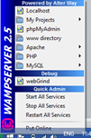

How to create database?

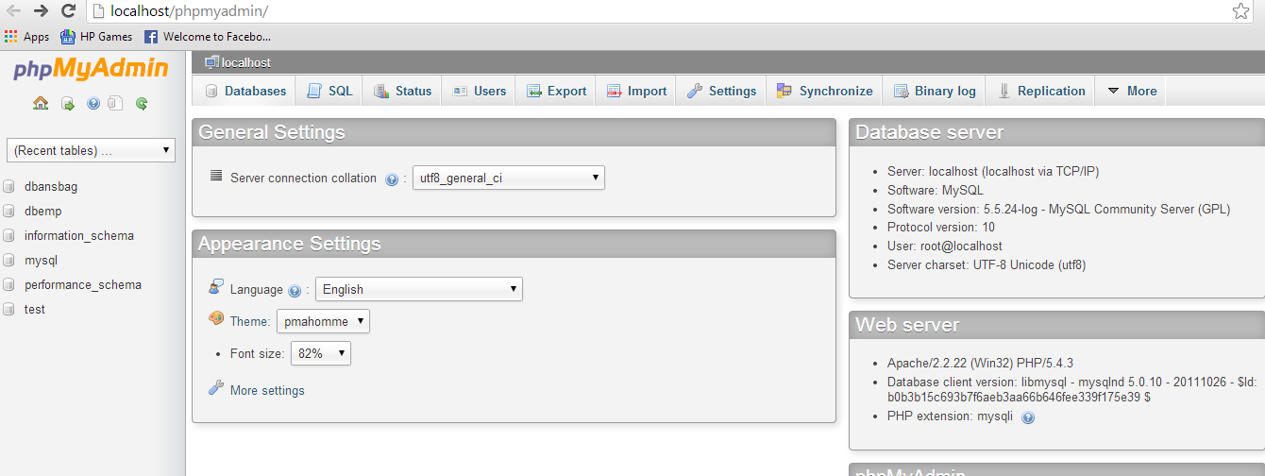

**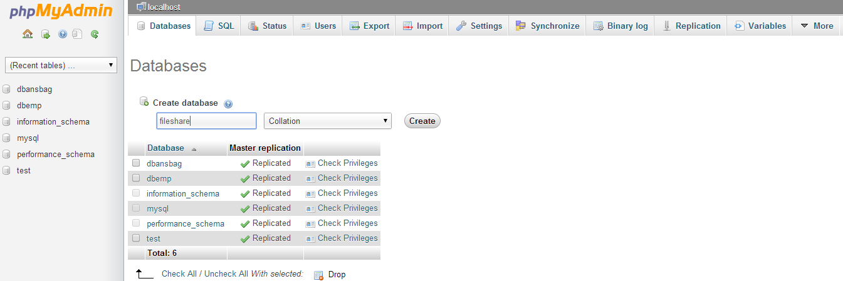**

**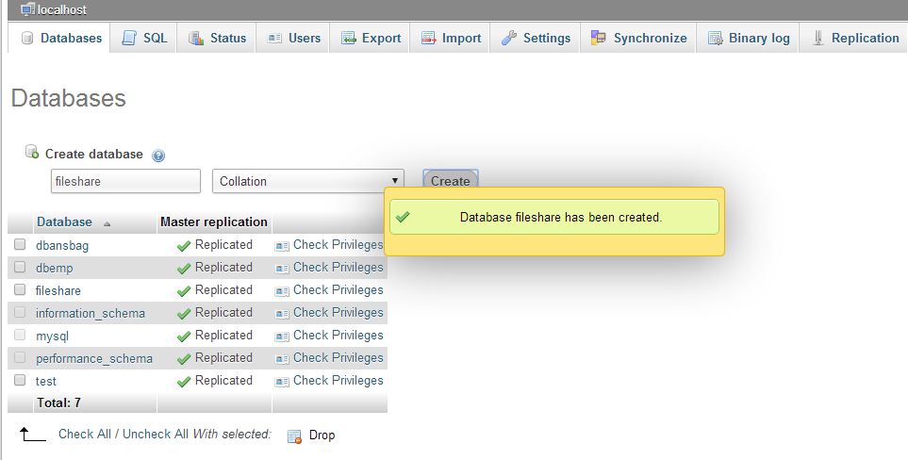**

**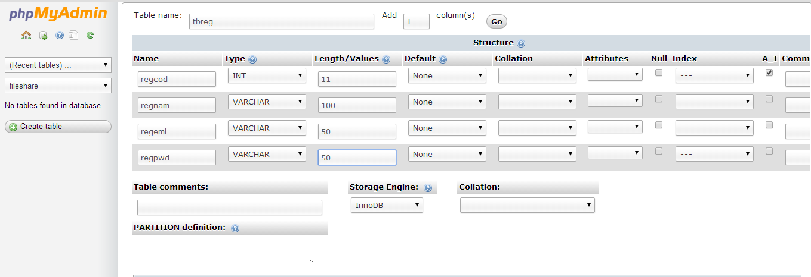**

**Conclusion**

The primary goal of this project report is to provide the detailed information about the project in very simplest way. With the help of SDLC life cycle it is easy to understand the requirement of the user. An effort is made is to keep the project flexible & user friendly which is easy to understand & modify. While developing this project a good use of Php language is made by using their advanced feature of programming respectively. We have gained a lot of practical knowledge from this project.

**Books References:**

**To bring the system to verge of completion ,the following items have been referred:**

**BOOKS**:-

PHP, MYsql, Apache(all in one) By SAMS, Julie c, Meloni, pearson

Beginning: PHP6,Apache,MYSQL By Elizabeth naramore, Jason yerner,

Web development yann le Scouarnec, Jeremy stolz

PHP6 and MYSQL bible By tim converse, joycee park,Michael k

**Web References:**

[www.php.net](http://www.php.net)

[www.w3schools.com](http://www.w3schools.com)